A
PROJECT REPORT ON
EXAM STRESS AND ITS IMPACT ON ACADEMIC PERFORMANCE.

Presented to:

In
The Partial fulfilment of the Requirements for the degree of

Master of Computer Application (M.C.A)

Submitted BY
Aachal Kiran Patil (24104001)
Mahesh Dnyandeo Bharambe (24104069)
Guide By
Prof. Shubham Adawal
To

G H Raisoni College of Engineering and Management, Jalgaon

Affiliated To

Kavayitri Bahinabai Chaudhari, North Maharashtra University, Jalgaon.

Academic Year: 2025-26



CERTIFICATE

This is to certify that Mr./Ms.___________________________________________
student of MCA (Master of Computer Application) from G H Raisoni College of Engineering and Management, Jalgaon has completed the __________________________________________________________________.
He / She has submitted satisfactory report in Partial fulfillment of the requirement for the award of the degree of Master of Computer Application (MCA) during academic year 2025-2026.

(Prof.Shubham Adawal) (Prof.Kalyani Neve)
Internal Guide Head,Dept.of MCA

External Examiner External Examiner

Index

Particulars | Page No.
1. Introduction  1.1 Overview of Research Problem  1.2 Objectives of Phase 2 | 4 to 5
2. Review of Phase 1 Work  2.1 Problem Statement  2.2 Research Objectives  2.3 Data Collection Methods | 6 to 7
3. Tools and Software Used | 8
4. Data Analysis and Interpretation  4.1 Descriptive Analysis (Tables, Charts, Graphs)  4.2 Interpretation of Results  4.3 Analytical Methods Used | 9 to 18
5. Findings | 19
6. Conclusion | 20
7. Limitations of the Study | 21
8. Future Scope | 22
9. References | 23
10. Appendices  10.1 Questionnaire / Survey Form | 24 to 25

Exam Stress and its Impact on Academic Performance

- Introduction :
Exam stress is a sense of anxiety and tension associated with taking an exam. It's natural to be anxious about future tests, exams, papers, or presentations. A modest amount of stress can, in fact, push you and motivate you to work harder. Exam anxiety becomes a problem when it impairs your capacity to perform and meet your academic and learning objectives (Joseph, 2019). Exam periods and exam scenarios are stressful for students, according to several studies of exam stress, which is especially true for oral exams. This makes you worry more, makes you anxious and depressed, causes you to lose sleep, makes you forgetful, irritated, overwhelmed, weary, and makes you feel out of control (Šimic & Manenica, 2012). In contrast to the concept of exam stress I have laid the relation with academic performance. Academic performance refers to how well students succeed in various academic subjects. Classroom performance, graduation rates, and standardized test results are commonly used by teachers and education administrators to assess achievement. Academic attainment is critical for young people's effective social development. Students who do well in school have a better chance of adjusting to adulthood and achieving professional and financial success (Ongayo, 1998).
In the body, stress causes specific mental and physiological reactions. Mild stress can help with cognitive tasks and performance, but chronic high stress can lead to neuropsychiatric disorders including anxiety and depression. Stressed students should be provided with an effective relaxation program as well as counseling services so that they may cope better with examination stress (Singh, et al., 2012). Similarly in terms of education, academic performance is an important aspect of schooling.
  - Overview of Research Problem :
Exam stress is a common issue among students, especially during examination periods. While moderate stress can motivate students, excessive stress negatively affects their mental health and academic performance. It can lead to problems such as anxiety, poor concentration, memory loss, and sleep disturbances. Students face pressure from parents, teachers, and competition, which increases stress levels. Additionally, lack of proper coping strategies and limited access to counseling services make it difficult for students to manage exam stress effectively.
Therefore, it is important to study the causes and impact of exam stress to help students improve their performance and overall well-being.
1.2 Objectives of Phase 2
- To measure the level of exam stress among students using collected data.
- To analyze the impact of exam stress on academic performance.
- To identify major factors causing exam stress such as time pressure, fear of failure, and competition.
- To study the relationship between stress levels and student demographics (gender, academic year, field of study).
- To evaluate the effectiveness of different coping strategies used by students.
- To apply statistical tools (charts, graphs, percentage analysis) for better understanding of data.
- To test hypotheses related to stress and academic performance.
- To interpret data findings to draw meaningful conclusions.
- To suggest practical solutions to reduce exam stress among students.
- To recommend institutional measures like counseling and stress management programs.

- Review of Phase 1 Work :

2.1 Problem Statement

Examination periods often bring heightened stress levels among students, which can significantly affect their cognitive abilities, emotional well-being, and ultimately, their academic performance. Students are frequently placed under immense pressure to perform well, not only to meet their own goals but also to satisfy expectations from parents, teachers, and society. While a manageable amount of stress can act as a motivator—helping students stay focused, disciplined, and goal-oriented—excessive or prolonged stress has the opposite effect. Chronic exam stress can impair critical mental functions such as memory retention, concentration, and decision-making. It can also manifest in physical and emotional symptoms, including sleep disturbances, fatigue, irritability, loss of appetite, anxiety, and depression.

The academic environment often emphasizes grades and rankings over holistic learning, creating a performance-based culture that fuels stress rather than alleviates it. This competitive pressure, combined with limited access to counseling services or mental health resources, leaves many students without the tools to manage exam-related stress effectively. Moreover, students are not always equipped with the coping skills needed to handle academic demands, especially during high-stakes assessment periods.

2.2 Objectives

- To identify the causes of exam-related stress among students.
Understand key stressors such as pressure to perform, fear of failure, parental expectations, or time constraints.

- To assess the level of exam stress experienced by students.
Measure the intensity and frequency of stress during exam periods using surveys or psychological scales.

- To examine the relationship between exam stress and academic performance.
Analyze how stress levels correlate with students' grades, test scores, and overall academic outcomes.

- To explore the coping strategies used by students to manage exam stress.
Identify techniques like time management, relaxation methods, or counseling services used by students.
- To investigate the differences in exam stress based on demographics.
Compare stress levels across age groups, gender, academic year, or field of study.

- To provide recommendations for reducing exam stress and improving academic performance.
Suggest strategies for educators, institutions, and students to create a healthier exam environment.

2.3 Data Collection and Methods

Data Collection : The task of data collection is begins after are search problem has been defined and research designed/ plan chalked out. Data collection is to gather the data from the population. The data can be collected of two types:
Primary Data:Primary data has collected directly from students through structured questionnaires.

Secondary Data: Secondary data has collected from the various website,previous research paper,large scale survey.

Source of Data: Primary through questionnaire and secondary through internal reports.

Structure of Questionnaires: The questionnaire has been framed and circulated to collect primary data. The questionnaire contains
- Direct questions
- Close end questions
- Multiple choice question

Sample Design: A sample design is a definite plan for obtaining a sample from a given population. Sample design may as well lay down the number of items to be included in the sample i.e. the size of the sample. Sample design is determined before data are collected. The population size is indefinite as the number of students who take the stress during exam. The sample size is 100. The respondents are from various location spread across jalgaon city.

- Tools and Software Used :

1. Google Forms (Online Survey Tool)
- Used for designing and distributing structured questionnaires to students.
- Helped in collecting primary data efficiently from a large number of respondents.
- Automatically organized responses in a systematic format.

2. Microsoft Excel (Data Analysis Software)
- Used for data entry, tabulation, and analysis of collected data.
- Helped in calculating percentages and organizing data into tables.
- Used to create charts and graphs such as pie charts and bar graphs for better visualization.

3. Microsoft Word (Documentation Software)
- Used for writing, formatting, and preparing the research report.
- Helped in organizing chapters, headings, and overall presentation of the project.

4. Basic Statistical Tools (Analytical Methods)
- Simple statistical techniques like percentage analysis and comparison methods were used.
- Helped in interpreting the relationship between exam stress and academic performance.

5. Internet Sources (Secondary Data Collection)
- Used to collect secondary data from research papers, journals, and websites.
- Provided theoretical support and background information for the study.

- Data Analysis and Interpretation :

4.1 Descriptive Analysis (Tables, Charts, Graphs)

Part A: Demographic Information of the respondents.
- Gender:
Gender | Number | Proportion %
Male | 56 | 51.4%
Female | 53 | 48.6%
Transgender | 0 | 0%
Total | 109 | 100%

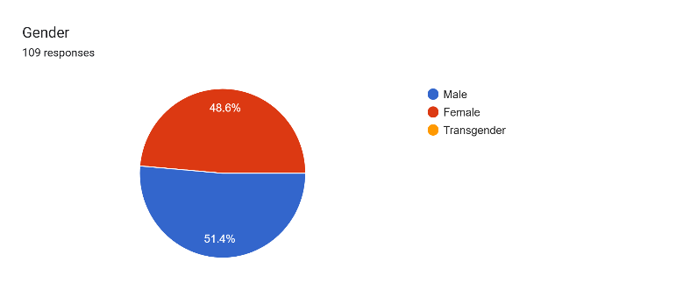
Result : Male participants (56; 51.4%) slightly outnumbered females.
Female participants (53; 48.6%) formed almost an equal proportion. No respondents identified as transgender (0%).
Interpretation: The gender distribution is well-balanced between male and female respondents.
The difference of 2.8% shows only a minor dominance of male participants.
The absence of transgender participants highlights a lack of representation from this group, possibly due to low visibility or reluctance to disclose identity.

- Academic Year:

Academic Year | Number | Proportion %
1st year | 20 | 18.3%
2nd year | 26 | 23.9%
3rd year | 12 | 11%
Final | 21 | 19.3%
Postgraduate | 30 | 27.5%
Total | 109 | 100%

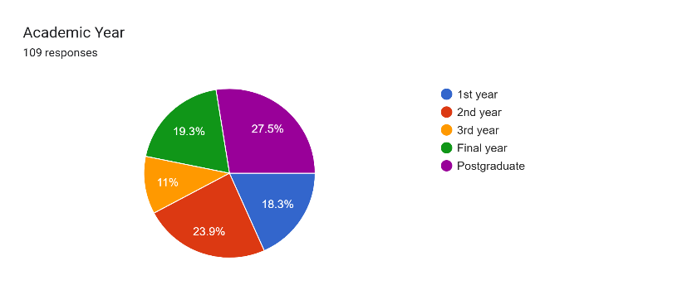
Result :The highest proportion of respondents are from Postgraduate (30; 27.5%).
The lowest proportion of respondents are from the 3rd year (12; 11%).
Other groups include 2nd year (26; 23.9%), Final year (21; 19.3%), and 1st year (20; 18.3%).
Interpretation: The sample covers all academic years, ensuring diversity in responses. Postgraduate students form the largest group, while 3rd-year students are the least represented. Overall, the distribution balances both undergraduate and postgraduate perspectives, making the study more comprehensive.
- Field of study:

Field of study | Number | Proportion %
Science | 47 | 43.1%
Commerce | 9 | 8.3%
Arts | 3 | 2.8%
Engineering | 18 | 16.5%
Other | 32 | 29.4%
Total | 109 | 100%

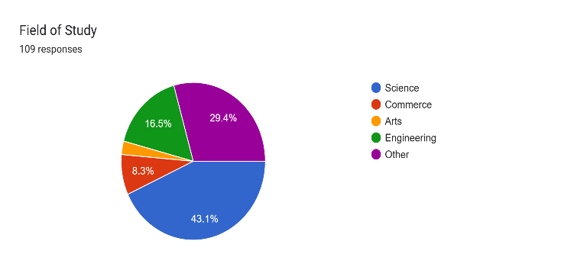
Result : The highest representation is from Science (47; 43.1%).
The lowest representation is from Arts (3; 2.8%).
Other significant groups include Engineering (18; 16.5%), Commerce (9; 8.3%), and Other fields (32; 29.4%).
Interpretation: The sample reflects a broad academic background, with the majority from Science, followed by Other fields and Engineering. Commerce and Arts students are least represented, indicating a slight skew toward Science disciplines.
- Type of institution:

Type of Institution | Number | Proportion %
Government | 30 | 27.5%
Private | 79 | 72.5%
Total | 109 | 100%

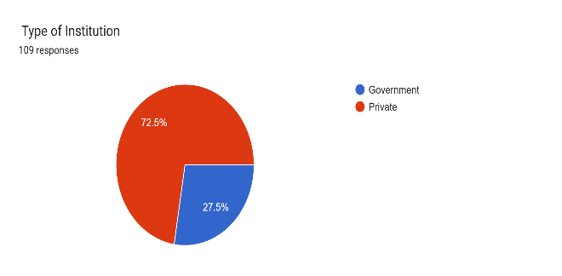

Result: Private institution students (79; 72.5%) form the majority of the sample.
Government institution students (30; 27.5%) represent a smaller proportion.
Interpretation:The sample is dominated by private institution students, while government institutions are less represented. However, perspectives from both sectors are included, allowing for useful comparisons.

Part B: Topic Related Questions

- How often do you fear failing an exam?

How often do you fear failing an exam? | Number | Proportion %
Never | 36 | 33%
Rarely | 25 | 22.9%
Sometimes | 40 | 36.7%
Always | 8 | 7.3%
Total | 109 | 100%

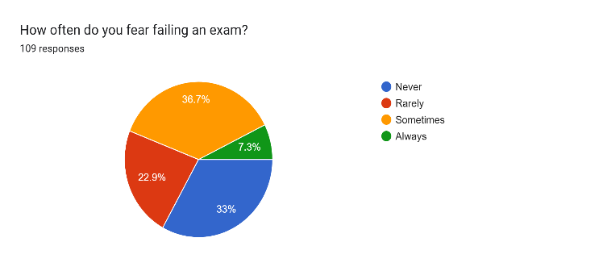
Result: The majority of students answered Sometimes (40; 36.7%).Never (36; 33%) is the second most common response.Rarely (25; 22.9%) shows moderate concern among some students. A small group Always (8; 7.3%) reported constant fear of failure.
Interpretation: Most students experience occasional exam fear, while some never fear failure, showing confidence. A small minority always fear failure, indicating higher anxiety. Overall, exam stress exists at varying levels, with most students in the “sometimes” and “never” categories.

- Which of the following cause you stress during exams?

Which of the following cause you stress during exams? | Number | Proportion %
Lack of preparation time | 46 | 42.2%
Competition with peers | 15 | 13.8%
Poor time management | 23 | 21.1%
Health Issues | 12 | 11%
Financial problems | 7 | 6.4
Other | 6 | 5.5%
Total | 109 | 100%

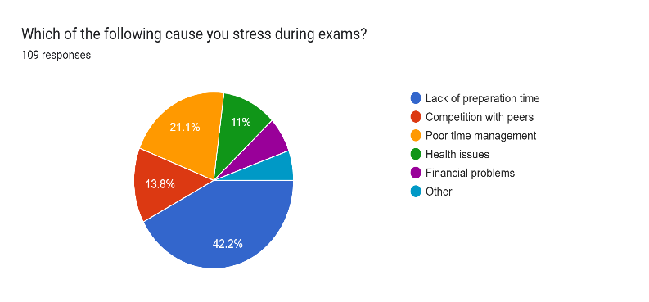
Result: The most common stress factor is Lack of preparation time (46; 42.2%).
Poor time management (23; 21.1%) is the second major cause.
Other factors include Competition with peers (15; 13.8%), Health issues (12; 11%), and Financial problems (7; 6.4%).
A small group reported Other causes (6; 5.5%).
Interpretation: Exam stress mainly stems from academic factors like lack of preparation and poor time management. Peer competition, health, and financial issues contribute less, showing stress is driven more by academic pressure than external factors.

- During exam periods, how often do you experience difficulty sleeping?

During exam periods, how often do you experience difficulty sleeping? | Number | Proportion %
Never | 23 | 21.1%
Always | 30 | 27.5%
Sometimes | 39 | 35.8%
Rarely | 17 | 15.6%
Total | 109 | 100%

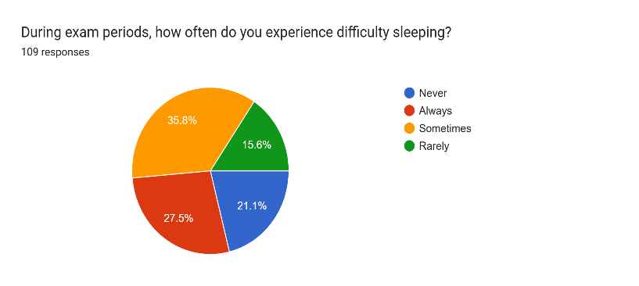
Result: The largest group reported Sometimes (39; 35.8%) experiencing sleep difficulty.
Always (30; 27.5%) indicates a significant portion faces constant sleep problems.
Never (23; 21.1%) shows some students are unaffected.Rarely (17; 15.6%) reported occasional issues.
Interpretation: Most students experience sleep disturbances during exams, mainly “sometimes” or “always.” A few are unaffected, while those who always struggle form a vulnerable group. Overall, sleep problems are a common sign of exam stress.

- Have you ever forgotten studied material in an exam due to stress?

Have you ever forgotten studied material in an exam due to stress? | Number | Proportion %
Yes | 69 | 63.3%
No | 40 | 36.7%
Total | 109 | 100%

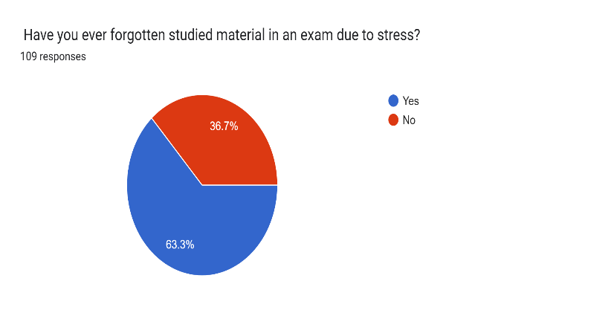
Result: A majority of students Yes (69; 63.3%) reported forgetting studied material due to stress. A smaller group No (40; 36.7%) did not face this issue.
Interpretation: Exam stress affects memory recall for most students, often impairing concentration and performance. A smaller group remains unaffected, likely due to better coping strategies, but overall stress commonly leads to memory lapses.

- In your last major exam, how satisfied were you with your performance?

In your last major exam, how satisfied were you with your performance? | Number | Proportion %
Very satisfied | 37 | 33.9%
Satisfied | 48 | 44%
Dissatisfied | 10 | 9.2%
Neutral | 14 | 12.8%
Total | 109 | 100%

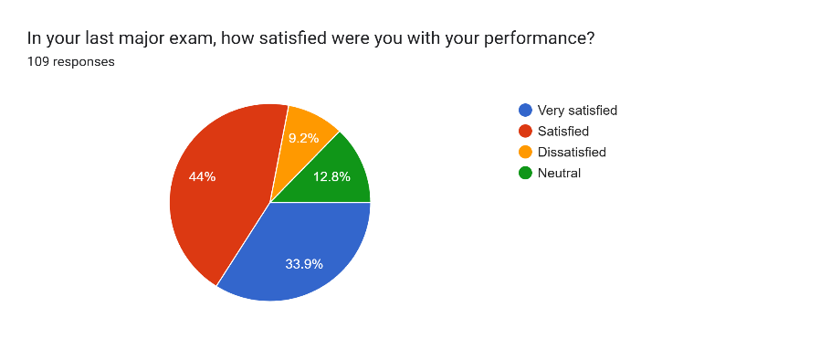
Result: Most students were either satisfied (44%) or very satisfied (33.9%) with their last exam performance, while fewer were neutral (12.8%) or dissatisfied (9.2%).
Interpretation: Overall, the majority felt positively about their performance, indicating good preparation and confidence, though a small portion expressed dissatisfaction or uncertainty.

- Which coping methods do you use during exams?

Which coping methods do you use during exams? | Number | Proportion %
Time management / study schedule | 68 | 51.9%
Group study / peer support | 23 | 17.6%
Meditation / relaxation techniques | 12 | 9.2%
Counseling services | 6 | 4.6%
Social media / entertainment | 11 | 8.4%
Other | 5 | 3.8%
Total | 109 | 100%

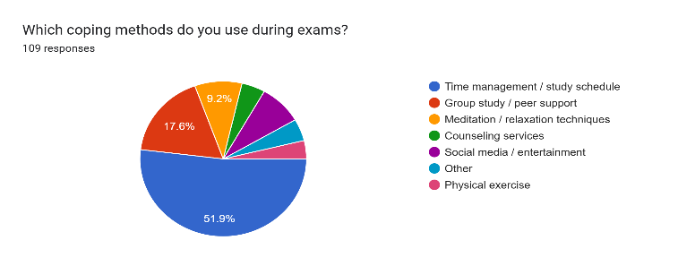
Result: The most common coping method is time management/study schedule (51.9%), followed by group study (17.6%). Fewer students rely on meditation (9.2%), social media/entertainment (8.4%), counseling (4.6%), or other methods (3.8%).
Interpretation: Most students cope by organizing their study time, while fewer adopt relaxation or counseling strategies. This suggests that exam stress is primarily managed through academic-focused methods rather than professional or therapeutic support.

- Rate your overall exam stress level on a scale of –

Rate your overall exam stress level on a scale of - | Number | Proportion %
1 | 12 | 11%
2 | 22 | 20.2%
3 | 32 | 29.4%
4 | 28 | 25.7%
5 | 15 | 13.8%
Total | 109 | 100%

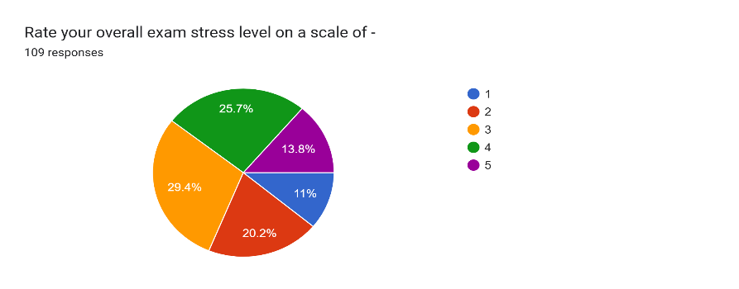
Result: Most students rated their exam stress at a moderate level (3 = 29.4%) or high level (4 = 25.7%), while fewer rated it low (1 = 11%, 2 = 20.2%) or very high (5 = 13.8%).
Interpretation: The results show that exam stress is common and generally moderate to high, with fewer students at the extremes, indicating that stress affects the majority but varies in intensity.

- How often do you feel overwhelmed or unable to cope with study load before exams?

How often do you feel overwhelmed or unable to cope with study load before exams? | Number | Proportion %
Never | 22 | 20.2%
Always | 30 | 27.5%
Rarely | 33 | 30.3%
Sometimes | 24 | 22%
Total | 109 | 100%

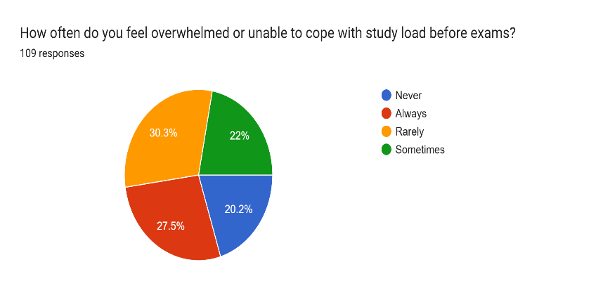

Result: The largest group reported feeling overwhelmed rarely (30.3%), followed by always (27.5%), sometimes (22%), and never (20.2%).
Interpretation: Most students experience being overwhelmed at least occasionally, with a significant portion facing it consistently. This shows that exam stress from study load is a common issue, though intensity varies among students.

- Does your institution provide counseling or stress management programs?

Does your institution provide counseling or stress management programs? | Number | Proportion %
Yes | 35 | 32.1%
No | 43 | 39.4%
Not Sure | 31 | 28.4%
Total | 109 | 100%

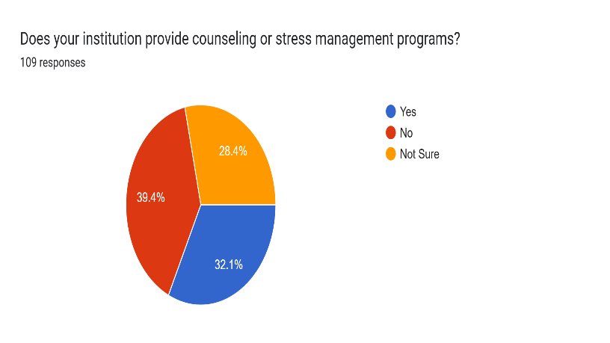
Result: About 32.1% of students reported that their institution provides counseling or stress management programs, 39.4% said no, and 28.4% were not sure.
Interpretation: The data shows that such programs are not widely accessible or visible, with many students either lacking access or unaware of available support, highlighting a gap in institutional stress management initiatives.

- How helpful would it be if your college organized stress management workshops before exams?

How helpful would it be if your college organized stress management workshops before exams? | Number | Proportion %
Not helpful | 32 | 29.4%
Very helpful | 77 | 70.6%
Total | 109 | 100%

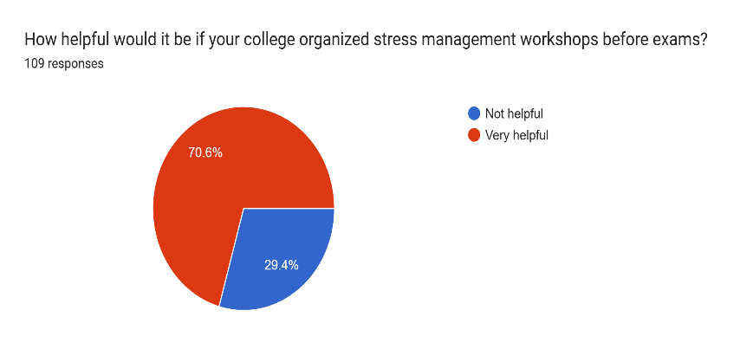
Result: A majority of students (70.6%) felt stress management workshops would be very helpful, while 29.4% considered them not helpful.
Interpretation: The findings indicate a strong demand for stress management workshops, showing that most students recognize their potential benefit in reducing exam-related stress.

  - Analytical Methods Used

1) Percentage Analysis
- Used to calculate the proportion of responses for each question.
- Helped in understanding trends like stress levels, causes, and coping methods.

2) Descriptive Analysis
- Data was presented using tables, charts, and graphs.
- Helped in summarizing and explaining the collected data clearly.

3) Comparative Analysis
- Used to compare stress levels across different groups such as gender, academic year, and field of study.

4) Correlation Analysis (Basic)
- Used to study the relationship between exam stress and academic performance.
- Helped in identifying whether stress has a positive or negative impact.

5) Graphical Representation
- Pie charts and bar graphs were used for visual interpretation of data.
- Made the results easy to understand.

6) Interpretation Method
- Each data set was followed by conclusions and interpretations to explain the findings in simple terms.

- Findings :

- Majority of students experience moderate to high exam stress.
- Lack of preparation time (42.2%) is the biggest cause of stress.
- Poor time management (21.1%) is the second major factor.
- Most students feel fear of failure sometimes (36.7%).
- 63.3% students forget studied material due to stress.
- Many students face sleep problems during exams.
- A significant number feel overwhelmed before exams.
- Stress negatively affects:
- Memory
- Concentration
- Confidence
- Majority of students are still satisfied with performance, showing moderate stress can help.
- Most used coping strategy is time management (51.9%).
- Very few students use counseling services (4.6%).
- Majority of students believe stress management workshops are helpful.

- Conclusion :

- Exam stress is a common and serious issue among students.
  - It affects both mental health and academic performance.
  - Moderate stress can be helpful and motivate students.
- High stress causes problems like:
- Anxiety
- Memory loss
- Sleep issues
- Poor concentration
- Main causes of stress are:
- Lack of preparation
- Poor time management
- Students mostly use self-help methods like:
- Study planning
- Group study
- Very few students use counseling or professional support.
- There is a lack of awareness and availability of stress management programs.
- Most students are interested in stress management workshops.
- Students are ready to adopt better coping strategies with proper guidance.
- Educational institutions should take active steps to reduce exam stress.
- A balance is needed between academic performance and mental well-being.

- Limitations of the Study :

• Limited Sample Size
The study is based on a sample of only 109 students, which may not fully represent the entire student population.

• Geographical Limitation
Data was collected only from students in Jalgaon city, so the findings may not be applicable to students from other regions or countries.

• Sampling Bias
The sample includes a higher proportion of students from private institutions and science backgrounds, which may affect the generalizability of results.

• Self-Reported Data
The data is based on students’ self-responses, which may include bias, exaggeration, or inaccurate reporting.

• Lack of Longitudinal Analysis
The study captures stress levels at one point in time and does not track changes over a longer period.

• Limited Psychological Measurement Tools
Standardized psychological scales or clinical tools were not used, which may affect the accuracy of stress level assessment.

• Exclusion of Other Factors
Factors such as family background, personality traits, mental health history, and socio-economic status were not deeply analyzed.

- Future Scope :

- Conduct study with larger sample size.

- Include students with larger sample size.

- Compare:
- Government vs Private institutions
- Different academic streams
- Use standard psychological tools/scales for better accuracy.
- Perform long-term (longitudinal) studies.
- Study effectiveness of:
  - Counseling programs
  - Stress management workshops
  - Develop mobile apps/tools for stress management.
  - Increase focus on mental health awareness.
  - Include teachers’ and parents’ perspectives in future research.

9. References :
1) Kumari, A., & Singh, S. K. (2022). Academic Stress among Senior Secondary Students with Reference to Gender, School Type, and Stream. Kala Sarovar, 25(04).
2) Lin, Jing and Chen, Qinghai (1995). “Academic Pressure and Impact on Students Development in China”, MCGILL Journal of Education, Vol. 30, No.2, pp.149-168.
3)Prabu, P. S. (2015). Academic Stress in Senior Secondary Students: Influence of Gender, School Type, and Academic Stream. International journal of humanities and social science invention, 4(10), 63-68.
4).Lee, M., & Larson, R. (2000). The Korean "examination hell": Long hours of studying, distress, and depression. Journal of Youth and Adolescence, 29, 249-27

5)Kumari, A. & Gartia, R. (2012). Relationship between stress and academic achievement of senior secondary school student.

10. Appendices :
10.1 Questionnaire
Appendix A: Questionnaire
Title: Survey on Exam Stress and Academic Performance
Section A: Demographic Information
- Gender
☐ Male ☐ Female ☐ Transgender
- Academic Year
☐ 1st Year ☐ 2nd Year ☐ 3rd Year ☐ Final Year ☐ Postgraduate
- Field of Study
☐ Science ☐ Commerce ☐ Arts ☐ Engineering ☐ Other
- Type of Institution
☐ Government ☐ Private

Section B: Exam Stress Related Questions
- How often do you fear failing an exam?
☐ Never ☐ Rarely ☐ Sometimes ☐ Always
- Which of the following causes you stress during exams?
☐ Lack of preparation time
☐ Competition with peers
☐ Poor time management
☐ Health issues
☐ Financial problems
☐ Other: __________
- During exam periods, how often do you experience difficulty sleeping?
☐ Never ☐ Rarely ☐ Sometimes ☐ Always
- Have you ever forgotten studied material in an exam due to stress?
☐ Yes ☐ No
- In your last major exam, how satisfied were you with your performance?
☐ Very satisfied ☐ Satisfied ☐ Neutral ☐ Dissatisfied
- Which coping methods do you use during exams?
☐ Time management / study schedule
☐ Group study / peer support
☐ Meditation / relaxation
☐ Counseling services
☐ Social media / entertainment
☐ Other: __________
- Rate your overall exam stress level (1–5)
☐ 1 ☐ 2 ☐ 3 ☐ 4 ☐ 5
- How often do you feel overwhelmed before exams?
☐ Never ☐ Rarely ☐ Sometimes ☐ Always
- Does your institution provide counseling or stress management programs?
☐ Yes ☐ No ☐ Not Sure
- How helpful would stress management workshops be?
☐ Very helpful ☐ Not helpful

